Global Tax System Support Manual

STATE STREET BANK AND TRUST COMPANY STANDARD OPERATIONAL PROCEDURE

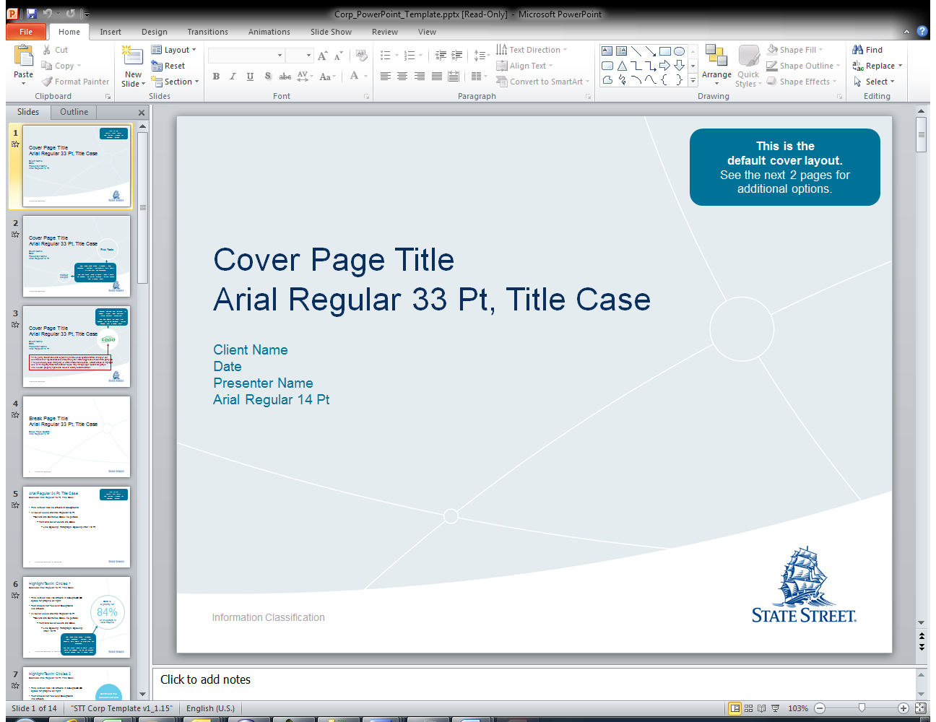

Division / Department: EMEA_Continuous_Operation_Support

Version: 1.0

Reviewed Date: Feb, 2016

Contents

Version Log 3

1. Introduction: 4

2. ISM Ticket & GSS notification 4

3. Reference 6

*Contact:* 6

*Pre-Requisites:* 6

4. Auto-sys Job Failure 6

*Purge Data Job Failure* 6

*Copy Data Job Failure* 9

*Import Data Job Failure* 10

*Export Data Job Failure* 12

*Extract Data Job Failure* 14

5. Database Failure 16

*Database cannot be connected;* 16

*Disk Space Shortage;* 17

*Deadlock release;* 18

*Exceed Maximum ID;* 20

*Database Low Performance;* 21

6. Server Failure 22

7. System Health Check Report Failure 22

8. Application Failure 23

9. Others 23

# Version Log

|  |  |  |  |  |
| --- | --- | --- | --- | --- |
| **No.** | **Changes** | **Author** | **Approver** | **Review Date** |
| 1 | Initial Draft | Huang, Yanzhuo (Candy) | Niamh, Daly | 25th Feb, 2016 |
| 2 | Update | Tong, Xinhui |  |  |
|  |  |  |  |  |
|  |  |  |  |  |
|  |  |  |  |  |

# Introduction:

This document is to give guidance when system level issue occurred during supporting Global Tax System. This document is maintained within EMEA CONTINOUS OPERATIONS team.

# ISM Ticket & Escalations

*Base on urgency and importance, the ISM ticket can be categorized differently, from a resilience support perspective, below are the most commonly used types of requests, as well as the manual of Command Center call.*

|  |  |  |  |  |
| --- | --- | --- | --- | --- |
| **Criteria & ETA** | **Action** | **Priority** | **Affect** | **Description** |
| Not very urgent, No close Deadline | Service Request | 3 | Low | For instance, account unlock |
| Over 2 hours buffer time | Incident Ticket | 3 | Medium | The issue happens at 3PM, and the fix time is required on 6PM |
| Within 1-2 hours buffer time | Incident Ticket | 2 | High | The issue happens at 3PM, and the fix time is required on 4:30PM |
| Within 1 hour buffer time | Incident Ticket | 1 | High | The issue happens at 4PM, and require fixing at 5PM with SLA/Client deliverables, this also require command center call to get all the concerned team aware and start to fix, phone number: xxxxxx  This type of incident would require a further root cause analysis from Lux AD team. |
| When MI is opened | Command Center Call | NA | NA | When issue happens, if it is identified by ECO team, ECO team will open a command center call and ask them to involve GSS team; if it is identified by GSS team(reported by user), GSS team will open command center call and involve our team; |

*Instruction to open a ticket:*

Login ISM: <https://ism.statestr.com/>

Go to My ticket or my group ticket to draft a new ticket on requirement and assign it to corresponding team.

*-*

*Command Center Call Process*

Firstly Email CommandCenter CommandCenter@statestreet.com, and then call 617-985-9204

Template as below:

|  |
| --- |
| Hi CommandCenter:  Could you help us to open a command center call for a production issue by *****? Please include the ***** team into the call.  The ticket number is IN******. |

# Reference

## Contact:

|  |  |
| --- | --- |
| **Name** | **Contact Information** |
| Oracle Exadata DB | Email: [IT-DMS-Exadata@StateStreet.com](mailto:IT-DMS-Exadata@StateStreet.com)  ISM Group: SSC-ETS-DB-EXADATA |
| Application Acceptance team | Email: ApplicationsAcceptance@StateStreet.com |
| Server Team | Email:  [ibunixl1@in.ibm.com](mailto:ibunixl1@in.ibm.com) (UNIX system)  [Windows_L1@StateStreet.com](mailto:Windows_L1@StateStreet.com) (Windows system)  ISM Group:  IBM-SMD-UNIX (UNIX system)  IBM-SMD-WINDOWS (windows system)  Emergency Number: |
| Application Owner | Name: Conzelmann, Franck  Phone: +352 464 0 10 621 |
| Lux AD team(Application Development team/L4 Support) | ISM Group:  SSC-ADM-EMA-LUX-L4  Email: [Luxembourg-AD@statestreet.com](mailto:Luxembourg-AD@statestreet.com) |
| Business Manager | Aurelie Paya  Phone: +352 464 0 10 533  Antoine Delporte  Phone: +352 464 0 10 143 |
| Lux IA support(L1 Support/GSS) | Email: [LuxembourgIASupport@statestreet.com](mailto:LuxembourgIASupport@statestreet.com)  ISM Group:  SSC-GSS-EMEA-LUX |
| Cloud Support Team(VM) | Email: [Cloud-support@StateStreet.com](mailto:Cloud-support@StateStreet.com)  Escalation information: http://cdt.statestr.com/?page_id=27#escalation |
| ESF Support | [ESFProductionSupport@StateStreet.com](mailto:ESFProductionSupport@StateStreet.com)  [ESF-Level2-Support@StateStreet.com](mailto:ESF-Level2-Support@StateStreet.com)  [ESF-Level3-Support@StateStreet.com](mailto:ESF-Level3-Support@StateStreet.com) |

## Pre-Requisites:

LAN ID should be active;

PROD Interchange id should be active;

GTS Database access should be active;

Folders access should be active;

# Autosys Job Failure

## Purge Data Autosys Job Failure

**Issue Description:**

Autosys job related to purge process has failed

**Reference:**

Below are the list of all the Purge related jobs;

|  |  |  |
| --- | --- | --- |
| **Job Description** | **Job Name (EU Version)** | **Job Name (US Version)** |
| GTS - Purge data older than last 7 days in WK_REVIEW_SUMMARY | gdcpw4535_uxgts310_o01_prg | gdcpw4535_uxgts310_o01_prg_us |
| GTS - Purge Tmp 511143 | gdcpw4535_uxgts310_o01_pur | gdcpw4535_uxgts310_o01_pur_us |
| Purge GTS2BCP files for GTSXDT - GTSXDTUS | lcppw3711_uxgts310_prg_gts2bcp |  |
| purge RPT files GTSXDT and GTDXDTUS | gdcpw4535_uxgts310_purge_rpt |  |

|  |  |  |  |
| --- | --- | --- | --- |
| **UX Code** | **Server Type** | **Server Name** | **DR Serve Name** |
| uxgts310 | Windows Server | lcppw3711 | dedpw3697 |
| uxgts311 | Windows Server | lcppw3711 | dedpw3697 |
| uxgts310 | Windows Server | gdcpw4535 | dc3pw3393 |

**Fix:**

If the job is with job type “purge file from folder “, please refer to the below folders where the files will be purged.

|  |  |  |
| --- | --- | --- |
| **Job Description** | **Job Name (EU Version)** | **Folder** |
| Purge GTS2BCP files for GTSXDT – GTSXDTUS - this job will purge all the files older than 5 days | lcppw3711_uxgts310_prg_gts2bcp | \\lcppw3711\GTSXDT\GTS2BCPIRE \\lcppw3711\GTSXDT\GTS2BCPUK \\lcppw3711\GTSXDT\GTS2BCPLUX \\lcppw3711\GTSXDTUS\GTS2BCPIRE \\lcppw3711\GTSXDTUS\GTS2BCPUK \\lcppw3711\GTSXDTUS\GTS2BCPLUX |
| Purge RPT files GTSXDT and GTDXDTUS – this job purges all files on all CSV folders for files older than 2 days. | gdcpw4535_uxgts310_purge_rpt | \\gdcpw4535\GTSXDT\RPTLUX \\gdcpw4535\GTSXDT\RPTIRE \\gdcpw4535\GTSXDT\RPTUK \\gdcpw4535\GTSXDTUS\RPTLUX \\gdcpw4535\GTSXDTUS\RPTIRE \\gdcpw4535\GTSXDTUS\RPTUK |

1. Check corresponding servers where the files are placed;
   1. server connection failed, go to Server Failure in page 21;
   2. server can be connected, go to 2;
2. Check if the folder is accessible; (removed, deleted, etc.);
   1. if the folder is accessible, go to 3;
   2. if the folder cannot be found, raise up a ticket to windows team;

If the job is with job type “Purge Data from Database”,

1. check corresponding servers where the database is located;
   1. server connection failed, go to Server Failure in page 21;
   2. server can be connected, go to 2;
2. Check if Database is accessible;

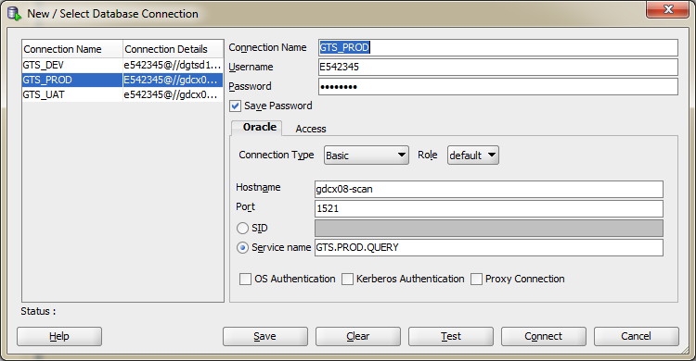

* 1. If DB connection is failed, go to Database unavailable – page 15;
  2. If DB connection is successful, go to 3;

1. Check if there are any data meets the purge condition

Regarding to the above table, you may use below query

GTS - Purge data older than last 7 days in WK_REVIEW_SUMMARY

Select* from GTS.wk_review_summary WHERE AS_OF_DATE='DD-MMM-YY'

GTS - Purge Tmp 511143

Select * from GTS.TMP_511143_DATA

GTS - Purge WK_EXTRACT_LOGS

Select * from GTS.WK_EXTRACT_LOGS

* 1. If the table contains no data, go to Auto-sys job system and check historical logs to see if this is a known issue, if yes, send query to application acceptance team and on-ice this job, and do a force start in the next working day; Also , an ISM ticket should be raised to Lux AD team for further checking;
  2. If the table contains designated data, check server where the auto sys script is placed, if the server is available, then send a ticket to Lux AD team to investigate;

1. After all are fixed, email application acceptance team to re-run the auto sys job;
2. If the reason is still not able to be identified after all the above have been checked., please refer to Others in last page;

|  |
| --- |
| To: Applications-Acceptance  Cc: EMEA_Continuous_Operation_Support  Subject: P02 Autosys Instance  Hi team,  Please FORCE START job <auto sys job name>, thanks!  Regards, |

## Copy Data Autosys Job Failure

**Issue Description:**

Auto-sys job related to copy file process has failed

**Reference:**

Below are the jobs related to Copy files

|  |  |  |  |
| --- | --- | --- | --- |
| **Job Description** | **Job Name (EU Version)** | **Files Copied from** | **Files Copied to** |
| Copy BCP2GTS Files for GTS Europe | lcppw3711_uxgts311_bcp2gts_eu | \\lcppw3711\GTSXDT\BCP2GTS | \\lcwfsv1\deptdata\GTSLIS\BCP2GTS |
| Copy CM NAV Files from to DRIVE1CMUK to GTSEUCMUK | lcppw3711_uxgts311_cp_euuk1 | \\ntplcw01\Common\CFS\M&G\COMPMAN | \\lcppw3711\GTSXDT\NAVLUX |
| Copy CM NAV Files from to DRIVE2CMUK to GTSEUCMUK | lcppw3711_uxgts311_cp_euuk2 | \\lcwfsv5\utm\LIS\Quilter | \\lcppw3711\GTSXDT\NAVLUX |
| Copy CM NAV Files from to DRIVE3CMUK to GTSEUCMUK | lcppw3711_uxgts311_cp_euuk3 | \\lcwfsv5\utm\LIS\Investec | \\lcppw3711\GTSXDT\NAVLUX |
| Copy CM NAV Files from to GDRIVECMLUX to GTSEUCMLUX | lcppw3711_uxgts311_cp_eulux1 | \\lxsjfk1dat\data\depts\extracts\navigator\GTS | \\lcppw3711\GTSXDT\NAVLUX |
| Copy CM NAV Files from to DRIVE2CMIRE to GTSEUCMIRE | lcppw3711_uxgts311_cp_euire1 | \\dusgh2dat\navigator | \\lcppw3711\GTSXDT\NAVLUX |
| Copy BCP2GTS Files for GTS US | lcppw3711_uxgts311_bcp2gts_us | \\lcppw3711\GTSXDTUS\BCP2GTS | \\lcwfsv1\deptdata\GTSLIS\BCP2GTS |
| Copy CM NAV Files from to DRIVE2CMIRE to GTSUSCMIRE | lcppw3711_uxgts311_cp_usire1 | \\dusgh2dat\navigator | \\lcppw3711\GTSXDTUS\NAVLUX |
| Copy CM NAV Files from to DRIVE1CMIRE to GTSUSCMIRE | lcppw3711_uxgts311_cp_usire2 | \\mf_a3e_01\Global\GTS | \\lcppw3711\GTSXDTUS\NAVLUX |
| Copy CM NAV Files from to DRIVE4CMIRE to GTSUSCMIRE | lcppw3711_uxgts311_cp_usire4 | \\mfmaog02\sunameri\temp | \\lcppw3711\GTSXDTUS\NAVLUX |
| Copy CM NAV Files from to GDRIVECMLUXG to GTSUSCMLUX | lcppw3711_uxgts311_cp_uslux1 | \\lxsjfk1dat\data\depts\extracts\navigator\GTS | \\lcppw3711\GTSXDTUS\NAVLUX |
| Copy CM NAV Files from to DRIVE1CMUK to GTSUSCMUK | lcppw3711_uxgts311_cp_usuk1 | \\ntplcw01\Common\CFS\M&G\COMPMAN | \\lcppw3711\GTSXDTUS\NAVLUX |

**Fix:**

1. Check if the server where the file is located and the server where the file is copied to can be connected;
   1. if any of the server gives connection failure message, please refer to Server Failure – page 21;
   2. if both servers can be connected, go to 2;
2. After all are fixed, email application acceptance team to re-run the auto sys job;

|  |
| --- |
| To: Applications-Acceptance  Cc: EMEA_Continuous_Operation_Support  Subject: P02 Autosys Instance  Hi team,  Please FORCE START job <auto sys job name>, thanks!  Regards, |

1. If the reason is still not able to be identified, after all the above have been checked., please refer to Others in last page;

## Export BCP Autosys Job Failure

**Issue Description:**

Auto-sys job related to export BCP file process has failed

**Reference:**

Below are the auto-sys jobs that are related to import file.

Files are created using the batch file:

\\lcppw3711\XDTDEV\autoSys.bat

This batch file is using the java code within \\lcppw3711\XDTDEV\GTSExaDatalib\GTSExaDatalib\GTSExadataMigration.jar

The files are created in below folders:

\\lcppw3711\GTSXDT\GTS2BCPIRE

\\lcppw3711\GTSXDT\GTS2BCPUK

\\lcppw3711\GTSXDT\GTS2BCPLUX

|  |  |
| --- | --- |
| Job name | Timing |
| lcppw3711_uxgts310_bcp1 | All days and every hours starting at minutes: 05,20,35,50 |
| lcppw3711_uxgts310_bcp6 | All days and every hours starting at minutes: 10,25,40,55 |
| lcppw3711_uxgts310_bcp11 | All days and every hours starting at minutes: 15,30,45,00 |

Files are uploaded using the batch file:

\\lcppw3711\XDTUSDEV\autoSys.bat

This batch file is using the java code within \\lcppw3711\XDTUSDEV\GTSExaDatalib\GTSExadataMigration.jar

The files are created in below folders:

\\lcppw3711\GTSXDTUS\GTS2BCPIRE

\\lcppw3711\GTSXDTUS\GTS2BCPUK

\\lcppw3711\GTSXDTUS\GTS2BCPLUX

The Autosys jobs for US are scheduled as below:

|  |  |
| --- | --- |
| Job name | Timing |
| lcppw3711_uxgts310_bcp1_us | All days and every hours starting at minutes: 05,20,35,50 |
| lcppw3711_uxgts310_bcp6_us | All days and every hours starting at minutes: 10,25,40,55 |
| lcppw3711_uxgts310_bcp11_us | All days and every hours starting at minutes: 15,30,45,00 |

**Fix:**

1. Check if the corresponding server can be connected, server name is listed on the start of the job name;
   1. If the server can be connected, go to 2;
   2. If the server cannot be connected, please refer to Server Failure – page 21;
2. If this is caused by performance issue
   1. Send email to Application-Acceptance team to kill current running job

|  |
| --- |
| To: Applications-Acceptance  Cc: EMEA_Continuous_Operation_Support  Subject: P02 Autosys Instance  Hi team,  Please kill job <auto sys job name>, thanks!  Regards, |

* 1. After job killing, new jobs match the time condition will be started. The performance of this job should be monitored again.
     1. If the new job still has the performance issue, a killing job should be done again (i.e. back to step a).
     2. If the new job doesn’t have performance issue, waiting for the job completion and go to step c.
  2. Check how many BCP files are under interim status. This could be checked by following SQL Query:

|  |
| --- |
| SELECT DISTINCT 'EU' AS INST, FUNDID, COMPONENTID, ASOFDATE  FROM GTS.TMP_BCP_DATA WHERE STATUS = 'R'  UNION  SELECT DISTINCT 'US' AS INST, FUNDID, COMPONENTID, ASOFDATE  FROM GTSUS.TMP_BCP_DATA WHERE STATUS = 'R'  ORDER BY INST, ASOFDATE DESC, COMPONENTID, FUNDID; |

Please note that this should be only done when all above 6 autosys jobs are under SUCCESS status. (No BCP file in generating period will be involved)

* 1. If there are at least one result from step c, the update SQL query file should be created and send email to IA team to update the status to N which could let the file to generate again.

The update SQL query for one file should like this:

|  |
| --- |
| UPDATE GTS.TMP_BCP_DATA SET STATUS = 'N'  WHERE FUNDID = 'ABCD ' AND COMPONENTID = 'AUTIS'  AND ASOFDATE = DATE '2016-11-14' |

Each BCP file need to reset the status should have an update query.

* 1. After updating status from IA team, the issue should be resolved this time.
  2. The root cause for the performance issue is under investigation.

1. If the reason is still not able to be identified, after all the above have been checked., please refer to Others in last page;

## Export CSV Report Autosys Job Failure

**Issue Description**

Autosys job related to export file process has failed.

**Reference:**

Below is the list of all export related jobs.

Jobs creating CSV files for Europe

|  |  |
| --- | --- |
| Job name | Timing |
| gdcpw4535_uxgts310_csv_eulu | All days and every hours every 15 minutes |
| gdcpw4535_uxgts310_csv_euire | All days and every hours every 15 minutes |
| gdcpw4535_uxgts310_csv_euuk | All days and every hours every 15 minutes |
| gdcpw4535_uxgts310_csv_eulu_s | All days and every hours every 15 minutes |
| gdcpw4535_uxgts310_csv_euire_s | All days and every hours every 15 minutes |
| gdcpw4535_uxgts310_csv_euuk_s | All days and every hours every 15 minutes |

CSV files are created under:

\\gdcpw4535\GTSXDT\RPTLUX

\\gdcpw4535\GTSXDT\RPTUK

\\gdcpw4535\GTSXDT\RPTIRE

Jobs creating CSV files for US

|  |  |
| --- | --- |
| Job name | Timing |
| gdcpw4535_uxgts310_csv_uslu_s | All days and every hours every 15 minutes |
| gdcpw4535_uxgts310_csv_usire_s | All days and every hours every 15 minutes |
| gdcpw4535_uxgts310_csv_usuk_s | All days and every hours every 15 minutes |
| gdcpw4535_uxgts310_csv_usuk | All days and every hours every 15 minutes |
| gdcpw4535_uxgts310_csv_uslu | All days and every hours every 15 minutes |
| gdcpw4535_uxgts310_csv_usire | All days and every hours every 15 minutes |

CSV files are created under:

\\gdcpw4535\GTSXDTUS\RPTLUX

\\gdcpw4535\GTSXDTUS\RPTUK

\\gdcpw4535\GTSXDTUS\RPTIRE

**Fix:**

1. Check if the server where the database is located can be connected;
   1. If the server can be connected, go to 2;
   2. If the server cannot be connected, please refer to Server Failure – page 21;
2. Check if the database can be connected;
   1. If the database can be connected, go to 3;
   2. If the database cannot be connected, please refer to Database Failure – page 15;
3. Check if the server where the file is exported to can be connected;
   1. If the server can be connected and folder is accessible, go to 4;
   2. If server cannot be connected, please refer to Server Failure – page 21;
4. Check if the script file that auto-sys job triggers still exists and active;
   1. If script is missing, raise up a ticket to UNIX/Windows team to fix;
   2. If the script is in the correct place, check if the script has been modified recently or not, if yes, check with Lux AD team on resolution;
5. After all are fixed, email application acceptance team to re-run the auto sys job;

|  |
| --- |
| To: Applications-Acceptance  Cc: EMEA_Continuous_Operation_Support  Subject: P02 Autosys Instance  Hi team,  Please FORCE START job <auto sys job name>, thanks!  Regards, |

1. If the reason is still not able to be identified after all the above have been checked, please refer to Others in last page;

## Extract Data Autosys Job Failure

**Issue Description:**

Autosys job related to extract data process has failed.

**Reference:**

Below is a list of all Extract data related auto-sys jobs

The batch scripts are running on Windows Server gdcpw4535

Log files are located on under \\gdcpw4535\vendor_apps\GTSXDT\AutosysLogs

Europe version

|  |  |  |
| --- | --- | --- |
| job name | Description | Scheduling |
| gdcpw4535_uxgts310_o01_hw1 | Holiday job | Monday to Friday 01:00am CET |
| gdcpw4535_uxgts310_o01_bl1 | Dayroll | Monday to Friday 01:02am CET |
| gdcpw4535_uxgts310_o01_ac1 | Asset Classification CI300 | Monday to Friday 02:02am CET |
| gdcpw4535_uxgts310_o01_ac2 | Asset Classification CI309 | Monday to Friday 00:00am CET |
| gdcpw4535_uxgts310_o01_ac3 | Asset Classification CI400 | Monday to Friday 02:00am CET |
| gdcpw4535_uxgts310_o01_ac4 | Asset Classification CI500 | Monday to Friday 04:30am CET |
| gdcpw4535_uxgts310_o01_ac5 | Asset Classification CIA00 | Monday to Friday 04:35am CET |
| gdcpw4535_uxgts310_o01_hmonit | Holiday Monitoring | Monday to Friday 06:45am CET |
| gdcpw4535_uxgts310_o01_ewe | Extract on week-end | Saturday 6am CET |
| gdcpw4535_uxgts310_o01_e11 | Extract 1 | Monday to Friday Every 2 hours from 06:00 to 22:00 CET |
| gdcpw4535_uxgts310_o01_e12 | Extract 1 | Monday to Friday Every 2 hours from 06:15 to 22:15 CET |
| gdcpw4535_uxgts310_o01_e13 | Extract 1 | Monday to Friday Every 2 hours from 06:30 to 22:30 CET |
| gdcpw4535_uxgts310_o01_e14 | Extract 1 | Monday to Friday Every 2 hours from 06:45 to 22:45 CET |
| gdcpw4535_uxgts310_o01_e15 | Extract 1 | Monday to Friday Every 2 hours from 07:00 to 23:00 CET |
| gdcpw4535_uxgts310_o01_e16 | Extract 1 | Monday to Friday Every 2 hours from 07:15 to 23:15 CET |
| gdcpw4535_uxgts310_o01_e17 | Extract 1 | Monday to Friday Every 2 hours from 07:30 to 23:30 CET |
| gdcpw4535_uxgts310_o01_e18 | Extract 1 | Monday to Friday Every 2 hours from 07:45 to 21:45 CET |
| gdcpw4535_uxgts310_o01_e21 | Extract 2 | Monday to Friday Every 2 hours from 06:00 to 22:00 CET |
| gdcpw4535_uxgts310_o01_e22 | Extract 2 | Monday to Friday Every 2 hours from 06:15 to 22:15 CET |
| gdcpw4535_uxgts310_o01_e23 | Extract 2 | Monday to Friday Every 2 hours from 06:30 to 22:30 CET |
| gdcpw4535_uxgts310_o01_e24 | Extract 2 | Monday to Friday Every 2 hours from 06:45 to 22:45 CET |
| gdcpw4535_uxgts310_o01_e25 | Extract 2 | Monday to Friday Every 2 hours from 07:00 to 23:00 CET |
| gdcpw4535_uxgts310_o01_e26 | Extract 2 | Monday to Friday Every 2 hours from 07:15 to 23:15 CET |
| gdcpw4535_uxgts310_o01_e27 | Extract 2 | Monday to Friday Every 2 hours from 07:30 to 23:30 CET |
| gdcpw4535_uxgts310_o01_e28 | Extract 2 | Monday to Friday Every 2 hours from 07:45 to 23:45 CET |

US version

|  |  |  |
| --- | --- | --- |
| job name | Description | Scheduling |
| gdcpw4535_uxgts310_o01_hw1_us | Holiday | Monday to Friday 1am EDT |
| gdcpw4535_uxgts310_o01_bl1_us | Dayroll | Monday to Friday 01:02am EDT |
| gdcpw4535_uxgts310_o01_ac1_us | Asset Classification CI300 | Monday to Friday 2:02am EDT |
| gdcpw4535_uxgts310_o01_ac2_us | Asset Classification CI309 | Monday to Friday 0:00am EDT |
| gdcpw4535_uxgts310_o01_ac3_us | Asset Classification CI400 | Monday to Friday 2:00am EDT |
| gdcpw4535_uxgts310_o01_ac4_us | Asset Classification CI500 | Monday to Friday 4:30am EDT |
| gdcpw4535_uxgts310_o01_ac5_us | Asset Classification CIA00 | Monday to Friday 4:35am EDT |
| gdcpw4535_uxgts310_o01_hmon_us | Holiday Monitoring | Monday to Friday 6:45am EDT |
| gdcpw4535_uxgts310_o01_ewe_us | Extract on week-end | Saturday 6am EDT |
| gdcpw4535_uxgts310_o01_e11_us | Extract 1 | Monday to Friday Every 2 hours from 06:00 to 22:00 CET |
| gdcpw4535_uxgts310_o01_e12_us | Extract 1 | Monday to Friday Every 2 hours from 06:15 to 22:15 EDT |
| gdcpw4535_uxgts310_o01_e13_us | Extract 1 | Monday to Friday Every 2 hours from 06:30 to 22:30 EDT |
| gdcpw4535_uxgts310_o01_e14_us | Extract 1 | Monday to Friday Every 2 hours from 06:45 to 22:45 EDT |
| gdcpw4535_uxgts310_o01_e15_us | Extract 1 | Monday to Friday Every 2 hours from 07:00 to 23:00 EDT |
| gdcpw4535_uxgts310_o01_e16_us | Extract 1 | Monday to Friday Every 2 hours from 07:15 to 23:15 EDT |
| gdcpw4535_uxgts310_o01_e17_us | Extract 1 | Monday to Friday Every 2 hours from 07:30 to 23:30 EDT |
| gdcpw4535_uxgts310_o01_e18_us | Extract 1 | Monday to Friday Every 2 hours from 07:45 to 23:45 EDT |
| gdcpw4535_uxgts310_o01_e21_us | Extract 2 | Monday to Friday Every 2 hours from 04:00 to 22:00 EDT |
| gdcpw4535_uxgts310_o01_e22_us | Extract 2 | Monday to Friday Every 2 hours from 04:15 to 22:15 EDT |
| gdcpw4535_uxgts310_o01_e23_us | Extract 2 | Monday to Friday Every 2 hours from 04:30 to 22:30 EDT |
| gdcpw4535_uxgts310_o01_e24_us | Extract 2 | Monday to Friday Every 2 hours from 04:45 to 22:45 EDT |
| gdcpw4535_uxgts310_o01_e25_us | Extract 2 | Monday to Friday Every 2 hours from 05:00 to 23:00 EDT |
| gdcpw4535_uxgts310_o01_e26_us | Extract 2 | Monday to Friday Every 2 hours from 05:15 to 23:15 EDT |
| gdcpw4535_uxgts310_o01_e27_us | Extract 2 | Monday to Friday Every 2 hours from 05:30 to 23:30 EDT |
| gdcpw4535_uxgts310_o01_e28_us | Extract 2 | Monday to Friday Every 2 hours from 05:45 to 23:45 EDT |

**Fix**:

1. Check if the server of the databases that data comes from and go to can be connected;
   1. If the server can be connected, go to 2;
   2. If the server cannot be connected, refer to Server Failure – page 21;
2. Check if the database where the data is extracted and imported can be connected;
   1. If any of the database has connection failure, refer to Database Failure – page 15;
   2. If both databases can be connected, go to 3;
3. Check in upstream data to see if there is any formatting conflict with current settings;
4. After all are fixed, email application acceptance team to re-run the auto sys job;

|  |
| --- |
| To: Applications-Acceptance  Cc: EMEA_Continuous_Operation_Support  Subject: P02 Autosys Instance  Hi team,  Please FORCE START job <auto sys job name>, thanks!  Regards, |

1. If the reason is still not able to be identified after all the above have been checked, please refer to Others in last page;

# *Extract Data Process Issue*

## Extract Data process too long

**Issue Description:**

Auto extract one, auto extract two and manuall extract process is running too long.

**Reference:**

Extract Data process could be split into two steps:

1) Extract data from MCH/FDR

2) Calculation based on the data from step 1

|  |  |
| --- | --- |
| Table **WK_PROCESSTRAIL** records the trail information of the process | |
| **Column** | **Description** |
| EXTRACT_ID | Unique ID could be used to track the process |
| REQUEST_NO | Could be ‘sp_extract1_main’, ‘sp_extract2_main’ or ‘sp_manual_import_process’ |
| START_TIME | Indicates the start time of the process |
| END_TIME | Indicates the end time of the process |
| EXTRACT_TIME | Indicates the completion time of first step. |
| FUNDLIST | Indicates the funds involved in the process |
| OPERATORID | Indicates the user trigger the process. For auto extract process, this value is ‘AUTO’, for manual extract process, this value is the user corp id. |

**Fix:**

1. Check the process under which part by query table WK_PROCESSTRAIL

|  |
| --- |
| SELECT EXTRACT_ID, REQUEST_NO, START_TIME, END_TIME, EXTRACT_TIME, FUNDLIST  FROM GTS.WK_PROCESSTRAIL  WHERE FUNDLIST LIKE ‘%<Fund ID>%’  AND REQUEST_NO = ‘<Request No>’ (Add this condition if we know) |

* 1. If EXTRACT_TIME is null, this means the first step is not completed. This may be caused by the extract is stuck in one OSA request call. Go to step 2 to review.
  2. If EXTRACT_TIME is not null, but END_TIME is null, this means the first step is completed, and the step 2 for calculation is still in progress. Go to step 3 to review.

1. Table WK_EXTRACT_LOGS records the track information for the first step. We can get the elapsed time for each OSA call, and draw a conclusion which OSA call consume much time or which OSA call still in progress.
   1. For auto extract process, if the latency impact the business work, the job could be killed by sending email to application-acceptance team, and then let user to do manual extract process for those funds.

**But please note** that the extract step uses multiple threads to do the extract operations. Even though the job is killed, the threads are still in running status. This should be a risk for the data saved into the database (The threads for auto extract process and manual extract process will both save data into the same table for a given OSA call)

1. Current Time - Extract Time is the elapsed time for calculation up to now.
   1. If current elapsed time is short, we’d expected this can be completed in minutes. In this situation, we could report first that the step 1 costs much time and the whole process should be completed in minutes.
   2. If current elapsed time is large, this may be caused by bad execution plan for some SQL query and results in long time on execution. Use below SQL query to find if any SQL queries have bad execution plan.

|  |
| --- |
| SELECT INST_ID, PARSING_SCHEMA_NAME, SQL_ID, PLAN_HASH_VALUE,  EXECUTIONS, ELAPSED_TIME, ROUND(ELAPSED_TIME / (CASE WHEN (EXECUTIONS = 0) THEN (1) ELSE (EXECUTIONS) END) / 1000000, 2) AS PER_ELAPSED_SECOND  FROM GV$SQL  WHERE SQL_ID = ‘<SQL ID>’ -- Add this where clause if you know the SQL ID  ORDER BY SQL_ID, PLAN_HASH_VALUE, PARING_SCHEMA_NAME, INST_ID; |

* 1. If bad execution plan find, create an Incident ticket and send email to Exadata support team to pin the good execution plan for a given SQL_ID.

# Database Failure

## Database cannot be connected;

**Issue description:**

Database is reported as cannot be connected

**Fix:**

If it is Production Database, a command center call is required; please refer to 2.ISM Ticket & GSS Escalations in page 2;

Open an ISM ticket to describe the issue and assign it to SSC-ETS-DB-EXADATA.

Login ISM with LAN Login

Go to Tab: MY GROUP TICKETS – New Service Request

Below is the ticket template:

|  |
| --- |
| Summary: GTS: <Ticket Number> - DB Connection Failure  Detail:  Hi Team,    The below database is not able to be connected, please urgently check and revert.  Server Name: O16XDA3  Host: gdcx08-scan  Port: 1521  Service Name: GTS.PROD.QUERY  Regards, |

If the database team is experiencing difficulty on fixing this issue and in doubt of other causes, please inform Lux AD team;

## Disk Space Shortage;

**Issue Description:**

When receiving an alert giving a notice that

1. The database space is over 85% usages;
2. The database is already not able to be connected due to space shortage;
3. The database has a high increase speed on space use;

The database space shortage contains but not limit to the above situation, when it is observed that the database space usage is not functioning as usual, a fix should be launched

**Fix:**

Open an ISM ticket to describe the issue and assign it to SSC-ETS-DB-EXADATA.

Input below query in database:

|  |
| --- |
| column "Tablespace" format a13  column "Used MB" format 99,999,999  column "Free MB" format 99,999,999  column "Total MB" format 99,999,999  select  fs.tablespace_name "Tablespace",  (df.totalspace - fs.freespace) "Used MB",  fs.freespace "Free MB",  df.totalspace "Total MB",  round(100 * (fs.freespace / df.totalspace)) "Pct. Free"  from  (select  tablespace_name,  round(sum(bytes) / 1048576) TotalSpace  from  dba_data_files  group by  tablespace_name  ) df,  (select  tablespace_name,  round(sum(bytes) / 1048576) FreeSpace  from  dba_free_space  group by  tablespace_name  ) fs  where  df.tablespace_name = fs.tablespace_name; |

Login ISM with LAN Login

Go to Tab: MY GROUP TICKETS – New Service Request

Below is the ticket template:

|  |
| --- |
| Summary: GTS DB Connection Failure  Detail:  Hi Team,    The below database is with low spaces, please urgently check and revert.  Server Name: O16XDA3  Table Space:  <add query return value>  Regards, |

If the database team is experiencing difficulty on fixing this issue and in doubt of other causes, please inform Lux AD team;

## Deadlock release;

**Issue Description:**

Database is experiencing deadlock.

**Fix:**

1. Run below query in the database;

|  |
| --- |
| SELECT * FROM  (SELECT b.inst_id,  b.session_id AS sid,  NVL(b.oracle_username, '(oracle)') AS username,  a.owner AS object_owner,  a.object_name,  Decode(b.locked_mode, 0, 'None',  1, 'Null (NULL)',  2, 'Row-S (SS)',  3, 'Row-X (SX)',  4, 'Share (S)',  5, 'S/Row-X (SSX)',  6, 'Exclusive (X)',  b.locked_mode) locked_mode,  b.os_user_name  FROM dba_objects a,  gv$locked_object b  WHERE a.object_id = b.object_id  ORDER BY 1, 2, 3, 4) WHERE USERNAME IN ('GTS','GTSUS'); |

If there are values returned, it means deadlock is there, and an ISM ticket needs to be raised immediately to release the process that deadlock occurs.

Open an ISM ticket to describe the issue and assign it to SSC-ETS-DB-EXADATA.

Login ISM with LAN Login

Go to Tab: MY GROUP TICKETS – New Service Request

Below is the ticket template:

|  |
| --- |
| Summary: GTS DB Deadlock Require release  Detail:  Hi Team,    The below query in the database is with deadlock, please urgently check and release the deadlock process.  Server Name: O16XDA3  Query: <>  Result:    Regards, |

If the database team is experiencing difficulty on fixing this issue and in doubt of other causes, please inform Lux AD team;

## Exceed Maximum ID;

**Issue Description:**

Connection failed

Run below query to check allowed maximum connection number:

|  |
| --- |
| Select value from v$parameter where name = 'processes'  Run below query to check current connection number:  Select count(*) from v$session |

**Fix:**

Open an ISM ticket to describe the issue and assign it to SSC-ETS-DB-EXADATA.

Login ISM with LAN Login

Go to Tab: MY GROUP TICKETS – New Service Request

Below is the ticket template:

|  |
| --- |
| Summary: Exceed Maximum Connection ID in GTS Database  Detail:  Hi Team,  GTS application O16XDA3 has exceeded the maximum connection, please urgently check and fix.  Query: <>  Result:  Regards, |

If the database team is experiencing difficulty on fixing this issue and in doubt of other causes, please inform Lux AD team;

## Database Low Performance;

**Issue Description:**

Database is reported as operating slow;

**Fix:**

1. Open an ISM ticket to describe the issue and assign it to SSC-ETS-DB-EXADATA.

Login ISM with LAN Login

Go to Tab: MY GROUP TICKETS – New Service Request

Below is the ticket template:

|  |
| --- |
| Summary: Database running slow  Detail:  Hi Team,    The below database is operating very slowly, please urgently check and fix, please be informed that we have a SLA behind in xx minutes,  Server Name: O16XDA3  Regards, |

1. If the reason that caused the slowness is the query running within GTS/GTSUS Schema, raise up another ticket to SSC-ETS-DB-EXADATA for AWR report and analyze further to see if this persists for period of time, if so, further check is required with Lux AD team on permanent fix resolution.

# Server Failure

**Issue Description:**

Server cannot be connected;

**Reference:**

|  |  |  |
| --- | --- | --- |
| **Server Type** | **Server Name** | **Server description** |
| Windows Server | lcppw3711 | Autosys Job |
| Windows Server | gdcpw4535 | Autosys Job |

**Fix:**

If it is Production Server, a command center call is required; please refer to 2.ISM Ticket & GSS notificationEscalations in page 2;

1. Open an ISM ticket to describe the issue and assign it to IBM-SMD-WINDOWS (windows system).

Login ISM with LAN Login

Go to Tab: MY GROUP TICKETS – New Service Request

Below is the ticket template:

|  |
| --- |
| Summary: GTS: <Ticket Number> - Server Connection Failure  Detail:    Hi Team,    The windows server <Server Name> is unable to be connected, please urgently check and revert.  [Possible Information here, such as when the issue happened]  Regards, |

If the Server team is experiencing difficulty on fixing this issue and in doubt of other causes, please inform Lux AD team;

# System Health Check Report Failure

**Issue Description:**

System Health Check Report cannot be generated automatically.

**Fix:**

Generate report manually by running query on desktop.

# Application Failure

**Issue Description:**

User can’t login application, and see below error message in browser

1) Proxy Error

2) Service Temporarily Unavailable

3) Other error messages

**Fix:**

1. **Check if all virtual machines of the application can be connected;**
   1. As the application is on cloud server,
      1. Do login operations several times in pc, and use IDF “__request=102” to get the virtual machine which can be login. See below example.
      2. For other virtual machines which don’t shown in the IDF result, check the cloud log size is normal or not (More than 400 KB should be a normal one which indicate that someone has login application via that virtual machine)
      3. Download the cloud log and tomcat related logs via cloud controller to check if any exception or error found (https://cloud.statestr.com).
      4. For virtual machines no error message found and can’t be connected, please raise email to Cloud Support Team to check. If much critical, refer to 10.

Use the below URL to get VM Name on which user is running;

GTS EU Instance 🡺 <https://cloud.statestr.com/gts/xml?__request=102>

GTS US Instance 🡺 <https://cloud.statestr.com/gtsus/xml?__request=102>

Example:

|  |
| --- |
| <?xml version="1.0" encoding="UTF-8" ?>  - <xdata created_by="GTS" created_at="Tue Feb 23 03:26:04 EST 2016" app="GTSWEB90077" profile="16585961" app_version="1.1.152" env="PROD" tran="0100d70a-4631-56cc179a-f788a710-d5764613b863" service="102">  - <rows start_index="0">  <row name="**gdcpc3030.statestr.com**" hits="10712570" start_time="20160223 03:26:04" last_hit_time="20160223 03:26:04" total_memory="1805189120" free_memory="1321969384" memory_usage="26.768372" tomcat_properties_service_link="" jvm_properties_service_link="" env_variables_service_link="" os_details_service_link="" wsf_properties_service_link="" esf_roles_service_link="" />  </rows>  </xdata> |

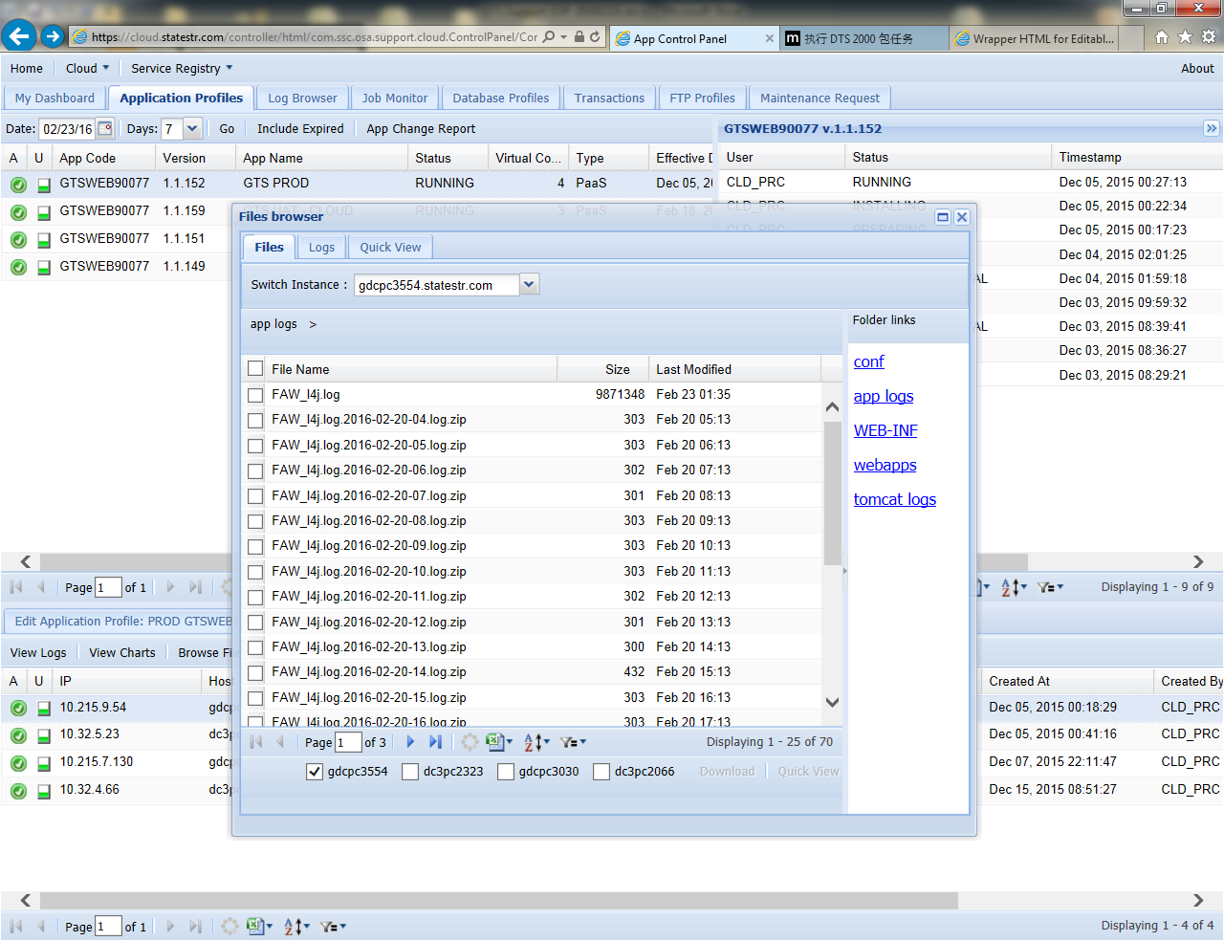

* 1. If the user account is locked, advise user to contact SAS team to unlock id.
  2. If the user account is active, but with different user menu of other same team members, check in ESF to see if the user is having same entitlement like other users;
  3. If the user account is active with correct entitlement, but with different user menu or is unable to login, contact ESF support team for update;

# Virtual Manufacturing (VM) Server connection Failure

**Issue Description**

The VM Server is reported as connection failed;

**Fix:**

If the issue is happened in PROD environment, open command center call directly as instructed on page 4;

Email Cloud team to report this with APP Code, this can be found in <https://cloud.statestr.com>

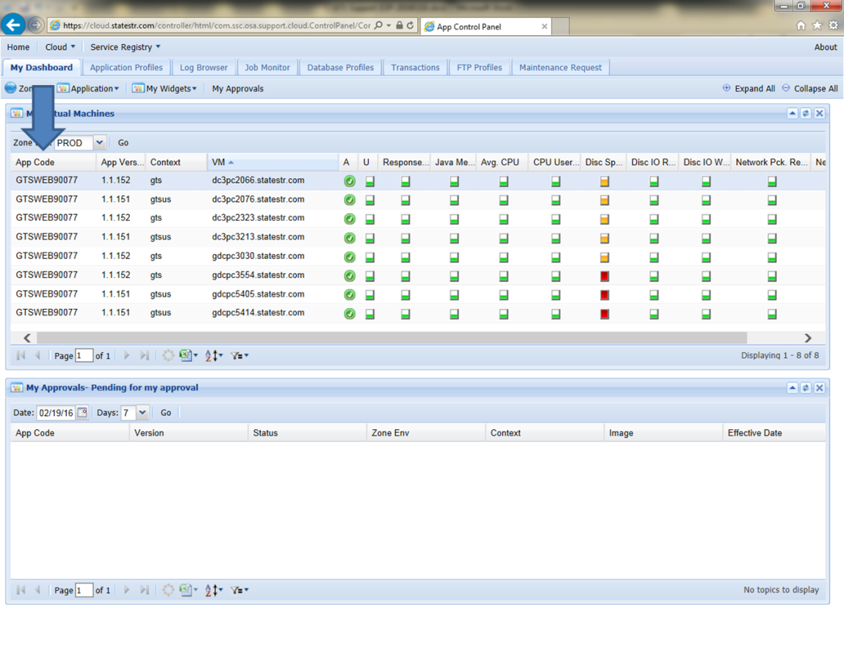

# Others

**Issue Description:**

Any issue that is not able to be fixed on support level;

**Fix:**

If there are any issues that is never seen before, please raise up an ISM ticket to Lux AD team and let them know the detailed symptom.

## GTS Code Review

sp_insertupdate_processtrail

### Extract_1

PKG_MCH_EXTRACT

sp_extract1_main (MCHG)

🡪 sp_extract1_status_queued (line 7594) : sp_update_extract1_status:

Find funds need to be extracted and set extract_1_status in wk_extract_scheule as ‘QUEUED’

🡪 sp_get_extract_1_fund_list

🡪 sp_insertupdate_processtrail('sp_extract1_main', 'MCHG');

🡪 sp_lock_funds (7621)

set lock_status in ad_fund as Y

🡪 sp_update_extract1_status(v_fundlist,'INPROGRESS')

🡪 sp_extract_511143 : sp_del_tmp_extract_detail

delete all funds’ extract detail log

>> sp_get_511143_fund_list >> sp_get_511143_fund_req_list >> fn_java_call_singleextract (singleExtract )>> sp_update_extract_asof_date (12537) >> sp_delete_prev_mch_records >> sp_populate_tmp_main_poolsub

🡪 sp_mch_prepare_extract_1

🡪 sp_insert_tmp_extract_detail

🡪 sp_extract_568001

**singleExtract**

### Extract_2

sp_extract2_main

🡪sp_extract2_status_queued

🡪 sp_get_extract_2_fund_list

### sp_manual_import_process

* ManualImportHandler.doManualImport
* pkg_mch_extract .sp_get_locked_funds : lock_status, nav_lock_status
* pkg_mch_extract.sp_get_blocked_funds
* clearTmpExtractTable:pkg_mch_extract.sp_man_imp_del_tmp_extract_det
* PKG_MCH_EXTRACT_CLD.sp_manual_import_wrapper

sp_call_manual_import('ZH3W,MCHG,NAVE,MCHT:ZKBC,MCHG,NAVE,MCHT','E491002','L9QP21','UGH#01C3', 'Pw8a2051');

* create job:(Import_Job_, pkg_mch_extract_cld.sp_call_manual_import) ☺ select * from ALL_SCHEDULER_JOB_RUN_DETAILS where job_name like 'IMPORT_JOB_%' order by log_date desc;
* pkg_mch_extract.sp_manual_import_process(L915,MCHG,NAVE,)
* fn_java_call_single_manual_imp (511143)
* sp_populate_tmp_511143: wk_mchrequest_511143, tmp_511143_data
* sp_update_extract_asof_date
* sp_insertupdate_processtrail(‘FDR’), sp_fdr_request, com.ssc.gts.extract.fdr.FDRExtractDao.fdrRequest

INSERT INTO stg_fdr_data,wk_fdr_data

* fn_java_call_singleextract(568001) ,3759 line - SP_EXTRACT_STORE
* sp_fdr_nav_data,: STG_NAVIGATOR_DATA, WK_NAV_UNREAL_GL
* sp_get_all_fund_req_list: Prepare input
* MCHT , MCHP
* sp_insertupdate_processtrail(‘sp_manual_import_process’)
* sp_update_extract_status, update tmp_extract_detail
* sp_up_manual_final_ex2_status, update wk_extract_schedule
* sp_get_fund_need_calculation, sp_month_end_check_cntd
* sp_parallel_wrapper(4196): CREATE JOB sp_pre_wrapper:

PKG_MCH_EXTRACT.sp_pre_wrapper('ZBPC,ALL','E491002','MANUAL','', 12072771);

pkg_calculate_autis_wrapper.

: pkg_calculate_autis_wrapper.sp_autis_wrapper(‘L915,ALL’, , ,MANUAL,NULL):

* update processtrail(AUTIS,CALCULATION)
* sp_populate_smf (1208)
* sp_del_fd_cal_val_for_asofdate
* pkg_calculate_autis.sp_calculate_auakg: pkg_util2.sp_populate_calc_hdr, sp_calculate_autis_dummy(3243)
* pkg_common_wrapper.sp_perform_rollup
* pkg_utl.sp_calculate_equalization_comp
* pkg_calculate_autis_wrapper.sp_run_all_autis
* sp_del_fd_cal_val_for_asofdate
* sp_common_wrapper(‘L915,ALL’,,OK,MANUAL)
* sp_update_tmp_extract_status_1

### Export BCP File

* Select funds from TMP_BCP_DATA Where status=N, then copy write data of tmp_bcp_data into csv file.
* update status, N,R,Y(E)

### Export CSV File

### Import NAV File

* com.ssc.gts.exadata.ProcessNavigatorFiles:

select from stg_navigator_data , if it has the data, then save the fund if the file is new-> check file, if start with CM and end with LIS, insert into stg_navigator_data, else save into failed list ->

* MERGE INTO stg_navigator_data from \\lcppw3711\GTSXDT\NAVLUX
* delete stg_navigator_data where fund is not in files

### Contingency Import

* Insert processtrail(‘COMP_CONT’)

## Table

1.

|  |  |  |
| --- | --- | --- |
| Table Name | Function | Vital Fields |
| wk_extract_schedule | Schedule, status of Ex1 & Ex2 |  |
| wk_processtrail | extract trail | extract_id |
| tmp_extract_detail | extract log of every fund | fundid |
| wk_extract_logs | detail log |  |
| ad_fund | all funds and their operation status | lock_status, nav_lock_status, mchcode,ACTIVE |
| ad_managerfund | Manager fund and its subfunds |  |
| ad_poolingfund | Pooling fund and its subfunds |  |
| wk_extract_detail |  |  |
| WK_REVIEW_SUMMARY | summary |  |
| WK_CALCULATION_HDR |  |  |

EUTIS



DDI

AKGC

AKG

IG

IP

TIE

AUTIS

568001 Extract

All Fundlist

Request Fundlist

FDR

sp_manual_import_process

SELECT OPERATIONTIME, THREADID, MESSAGE FROM (  
SELECT OPERATIONTIME, THREADID, MESSAGE, MAX(OPERATIONTIME) OVER (PARTITION BY THREADID) AS MAX_TIME, MIN(OPERATIONTIME) OVER (PARTITION BY THREADID) AS MIN_TIME  
FROM (  
SELECT *  
FROM GTS.WK_EXTRACT_LOGS  
WHERE SUBSTR(MESSAGE, 1, 8) = '10086149'  
  AND OPERATIONTIME > TO_DATE('2016-12-16 13:23:00', 'YYYY-MM-DD HH24:MI S')  
)  
)  
WHERE OPERATIONTIME = MAX_TIME OR OPERATIONTIME = MIN_TIME  
ORDER BY OPERATIONTIME;

GTS WEB

